SE 3070

Case studies in Software Engineering

2021s2_REG_WE_13

**Background**

The smart ticketing system is a system that is created for making transportation more convenient. The system lies in the center of a complex interconnected IOT network which helps to automate the process of ticketing of Metros, trains, busses and all other transportation methods. A customer of this system has 2 main methods to pay for the journeys that they take.

1. Day pass:

In this method, customer can buy a day pass from a point at major transportation hubs.(bus stations / metro stations etc.). Using this pass , the customer can travel any distance in the network for 24 hours using the day pass as the payment method.

1. Smart card:

In the smart card method, the customer can pays an initial amount for the transportation provider , and open a digital wallet. The customer can top up the wallet at a recharge point. Also the customer can recharge using the service API from the browser or from the mobile application. The customer will insert the smart card when starting the journey of any transportation mode . The customer will again insert the smart card at the exit destination. The system will calculate the prize for the journey based on the starting destination and the end destination. The calculation is done as a flat rate for a certain distance and for each distance beyond that a price for every kilometer. After making the payment the app will update the journey history of the customer.

Foringer is a special kind of customer . He can use both the above methods , but incase they don't have a personal wallet they can buy an foreign express pass. The foreign express pass can be used throughout the stay in the country and can be used to travel anywhere in the country using it as the payment method. This can only be brought by foreigners and has a price based on their visa. Once the visa expires the foreign express pass will also expire.

# Use case diagram

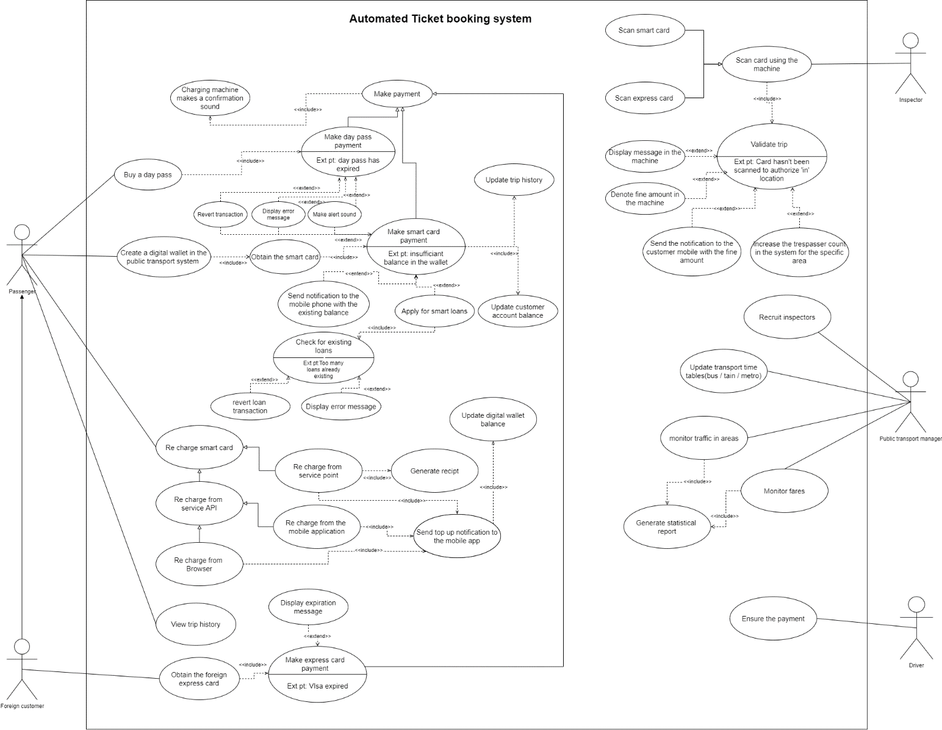

# User Scenarios

|  |  |
| --- | --- |
| **Use Case ID:** | PTS001 |
| **Use Case Name:** | Making payment with smart card |
| **Summary:** | This use case covers the scenario of the passenger making the payment with the with the smart card(payment token) |
| **Priority:** | 1 |
| **Primary Actor:** | Passenger (A registered user) |
| **Secondary Actor:** | Inspector |
| **Frequency of Use:** | Regularly |

|  |
| --- |
| **Preconditions** |
| 1. The passenger should have opened a digital wallet with the transport provider by paying the initial amount and obtained the smart card. 2. The passenger should be logged into the mobile app. |

|  |  |
| --- | --- |
| **Main Success Scenario** | |
| **Step** | **Actions** |
| **1** | The passenger inserts their smart card when entering to the bus |
| **2** | The passenger inserts their smart card at the exit location |
| **3** | The system calculates the price based on the exit and entrance location |
| **4** | The system checks whether the available balance is sufficient |
| **5** | The system deducts the amount from the customers wallet |
| **6** | Charging machine makes the confirmation sound |

|  |  |
| --- | --- |
| **Extensions** | |
| **Step** | **Actions** |
| **4.1** | If the available balance is insufficient |
| **4.1.a** | Revert the transactions in the system |
| **4.1.b** | Display an error message in the charging machine |
| **4.1.c** | Make an alert sound |
| **4.1.d** | Send notification to the mobile app with the available balance |
| **4.1.e** | Display the smart loan facility |
| **4.1.e.i** | Check for existing loans |

|  |
| --- |
| **Post conditions** |
| 1. Updated trip history information should be available for the user to view |

|  |
| --- |
| **Special Requirements** |
| 1. The passengers are privileged to take a loan during a trip too in case of a scenario they got a situation to travel longer and more expensive than they initially expected. |

|  |
| --- |
| **Other Notes (Assumptions, Issues,)** |
| * It is assumed that the customer haven’t already taken a loan |

|  |  |
| --- | --- |
| **Use Case ID:** | PTS002 |
| **Use Case Name:** | Recharging the Smartcard account at a service point` |
| **Summary:** | A Passenger Recharges his/her Account Using a Reload Machine |
| **Priority:** | 1 |
| **Primary Actor:** | Passenger |
| **Secondary Actor:** | - |
| **Frequency of Use:** | Occasionally |

|  |
| --- |
| **Preconditions** |
| 1. User should know their account no in order to recharge the account. 2. Users should have valid bank notes to enter the reload machine. |

|  |  |
| --- | --- |
| **Main Success Scenario** | |
| **Step** | **Actions** |
| **1** | The user selects the smartcard payment option at the top-up machine. |
| **2** | The user enters the account number to the reload machine |
| **4** | The system asks the user to input the bank notes to the machine one after one. |
| **5** | The amount inputted is shown on the screen for the user to check |
| **6** | The user confirms the amount shown on the screen to be credited to his/her account. |
| **7** | The system will generate a receipt |
| **8** | The system shows the success notification for the mobile app |

|  |
| --- |
| **Post conditions** |
| 1. Update the digital wallet balance. |

|  |
| --- |
| **Special Requirements** |
| 1. Only the SriLankan currency(LKR) is accepted at service point. |

|  |
| --- |
| **Other Notes (Assumptions, Issues,)** |
| 1. The users can also top-up the account balance using a credit/debit card at the service point or using the service providers API |

|  |  |
| --- | --- |
| **Use Case ID:** | PTS003 |
| **Use Case Name:** | Make Day Pass Payment |
| **Summary:** | This use case covers the scenario of the passenger making the payment with the day pass |
| **Priority:** | 2 |
| **Primary Actor:** | Passenger |
| **Secondary Actor:** | - |
| **Frequency of Use:** | Occasionally |

|  |
| --- |
| **Preconditions** |
| * Buy a day pass. |

|  |  |
| --- | --- |
| **Main Success Scenario** | |
| **Step** | **Actions** |
| **1** | The user swipes the day pass at the charging machine at the exit location |
| **2** | The system checks whether the day pass is already expired |
| **3** | The charging machine makes the confirmation sound |

|  |  |
| --- | --- |
| **Extensions** | |
| **Step** | **Actions** |
| **2.1** | If the day pass is expired |
| **2.1.a** | Revert transaction |
| **2.1.b** | Display an error message in the charging machine |
| **2.1.c** | Make an alert sound |

|  |
| --- |
| **Post conditions** |
| 1. Update the total price of the transportation route |

|  |  |
| --- | --- |
| **Use Case ID:** | PTS004 |
| **Use Case Name:** | Make Express Card Payments |
| **Summary:** | If the passenger is a foreign customer, he has to pay the bus fare through Express Card |
| **Priority:** | 1 |
| **Primary Actor:** | Foreign Passenger |
| **Secondary Actor:** | - |
| **Frequency of Use:** | Occasionally |

|  |
| --- |
| **Preconditions** |
| * Customer should be a foreign customer * There should be sufficient balance |

|  |  |
| --- | --- |
| **Main Success Scenario** | |
| **Step** | **Actions** |
| **1** | Passenger makes the payment through express card |
| **2** | The system checks whether the Visa card is expired or not |
| **3** | System makes a confirmation sound when the payment is success |

|  |
| --- |
| **Post conditions** |
| * Visa card balance must be updated |

|  |
| --- |
| **Special Requirements** |
| * In order to use Express Cards, the passenger should be a foreign passenger |

|  |  |
| --- | --- |
| **Use Case ID:** | PTS005 |
| **Use Case Name:** | Validate Trip |
| **Summary:** | When a passenger made |
| **Priority:** | 3 |
| **Primary Actor:** | Inspector |
| **Secondary Actor:** | - |
| **Frequency of Use:** | Regularly |

|  |
| --- |
| **Preconditions** |
| * The passenger has made the payment * The payment should be successful |

|  |  |
| --- | --- |
| **Main Success Scenario** | |
| **Step** | **Actions** |
| **1** | The user makes a payment |
| **2** | Inspector scan the smart card or express card using a scanning machine. |
| **3** | Checks the amount with the scanned amount |
| **4** | If the value is correct, inspector validate the trip. |

|  |  |
| --- | --- |
| **Extensions** | |
| **Step** | **Actions** |
| **4.1** | In case if the value is incorrect a notification will be sent to the user and that additional charge will be added to the next trip. |

|  |
| --- |
| **Post conditions** |
| * Trip confirmation message should be sent to the customer |

|  |
| --- |
| **Other Notes (Assumptions, Issues,)** |
| * The system will auto calculate the trip fare. * If the card hasn’t been scanned the location it will be notified to the inspector when he san it manually |

|  |  |
| --- | --- |
| **Use Case ID:** | PTS006 |
| **Use Case Name:** | Generate statistical report |
| **Summary:** | Public transport manager generates a report to monitor traffic and trip fare |
| **Priority:** | 5 |
| **Primary Actor:** | Public transport manager |
| **Secondary Actor:** |  |
| **Frequency of Use:** | Regularly |

|  |
| --- |
| **Preconditions** |
| * Should have records of trip fares and traffic around the city |

|  |  |
| --- | --- |
| **Main Success Scenario** | |
| **Step** | **Actions** |
| **1** | Public transport manager takes details of trip fare |
| **2** | Public transport manager takes details of traffic details |
| **3** | After analyzing those details, he creates a statistical report |
| **4** | Updates the transport time as well |

|  |
| --- |
| **Post conditions** |
| * Those statistical data must be taken by observing several records |

# User interfaces

## High fidelity interfaces

### Some business functions of public transport manager

### Some business functions of user

## Login

### Recharge smart card

### Registration

### View past trips

## Transport manager

### Manage vehicles / routes

### Manage Inspectors

## Low fidelity interfaces

## Apply for loan

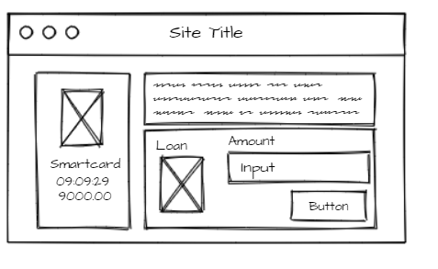

# Sequence diagram

|  |  |  |
| --- | --- | --- |
| Registration number | Name | Contribution |
| IT19132310 | Hettiarachchi L.S | * Usecase diagram * UI – Web * User scenario * Report |
| IT19139036 | Jayadeva A.S.V | * Class diagram * User scenario * Report |
| IT19120980 | Palliyaguruge D.N | * Sequence Diagrams * User Scenario * Report |
| IT19146898 | Fernando K.D.A.B | * UI - mobile * Report |